Go to Appearance > Menu to set "Primary Menu"
Central News Hub

SPECIAL: Kolkata Diary By Mohammed Reza Amirinia (Part II)
8 October 20208 October 2020
Uncategorized

With a significant population, India has already been facing a great task in dealing with the damages caused by the impacts of the virus and maintaining social distancing. To make matters worse, another natural disaster hit West Bengal on 20th May as the coastal areas of the states of Odisha and the West Bengal suffered the heavy impacts of one of the strongest cyclones in decades. The hurricane caused by super cyclone “Amphan” destroyed fishing villages, homes and farms, brought down the power lines and damaged roads and highways. The high-speed winds of up to 190 Km/h caused surges in storm and heavy rainfall, raising the sea level and flooding agricultural land, farms and towns. The poor infrastructure of Kolkata could not cope with the consequence of overflowing water in the streets. Many neighbourhoods such as Kumotuli were devastated. Homes and workshops were swamped in the flooding water. People have become both jobless and homeless.
Jaydeep felt guilty and had to raise a new initiative to help his fellow citizens and compatriots. He had to expand and move his relief efforts to the Sundarbans. The Sundarbans is a delta in the Bay of Bengal, formed by the confluence of three rivers: the Ganges, Brahmaputra and Meghna. It is partly in India and another part of this unique ecological area is located in Bangladesh. The four areas in Sundarbans have been registered as UNESCO World Heritage sites, because of their rich ecological importance, mangrove forests and wildlife sanctuaries. The Sundarbans National Park has been a centre of world attention because of the tiger and biosphere reserve, and faunal wildlife.
Sundarbans is protected from the sea by the wide range of mangrove forests which is covered by Sundari trees with broad green leaves. Sundari in Bengali means beautiful. The protection of these beautiful trees is vital to the livelihoods of the farmers and agriculture in Sundarbans. Unfortunately, the storm has also had a devasting impact on the mangrove forest, damaging many Sundari trees. As a result, the salt water has penetrated the farmland, destroying all cultivation. There are approximately 200 villages with an overall population of over 2 million in Sundarbans. The farmers in these lands rely heavily on their agricultural investment and hard work. Jaydeep explained that it takes at least three years before Sundarbans can recover from the shock and devastation of the cyclone.
The impact of the Cyclone has endangered the life and the well-being of not only the inhabitants of Sundarbans but also the tigers and all other wildlife. The ecology of the area has been disturbed, which will take a long time to recover. Many animals such as wild hogs, boars and deer were killed following the cyclone. As a result, the tigers are not able to hunt for food as before and attack local villages. This has added more danger and pain for the inhabitants of Sundarbans who became homeless and without proper shelter. Jaydeep told me that they have an expression in the area that “the Law of nature is the law of the land.” He continues saying, “Nobody can control this wild area.” Many parts of Sundarbans are no man’s land due to the extreme wild and dangerous tigers and other animals around.
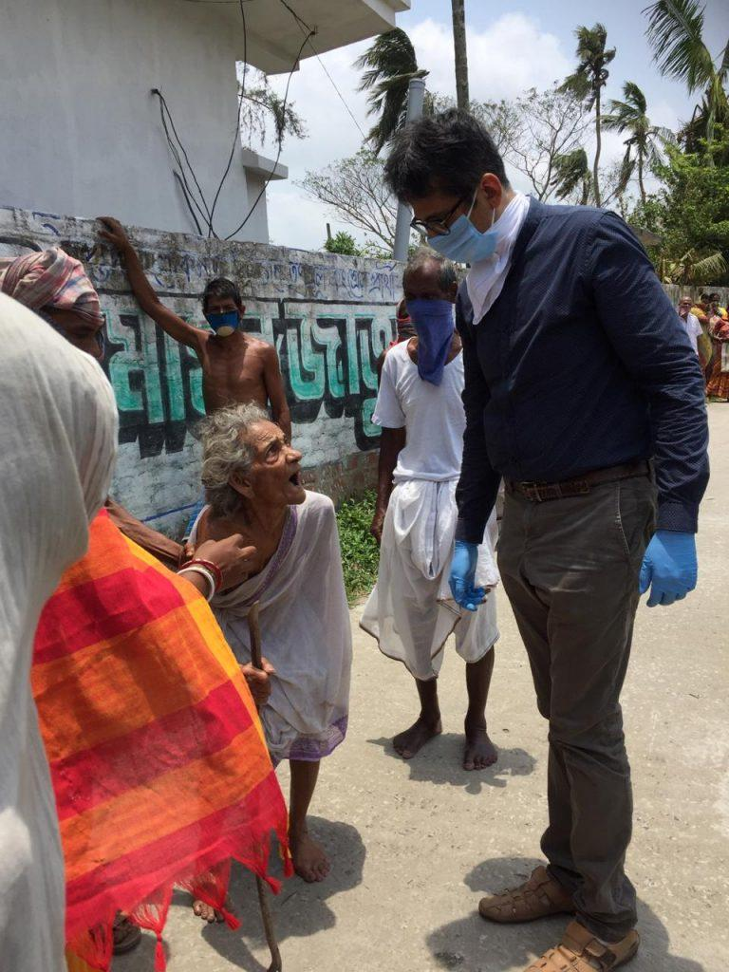
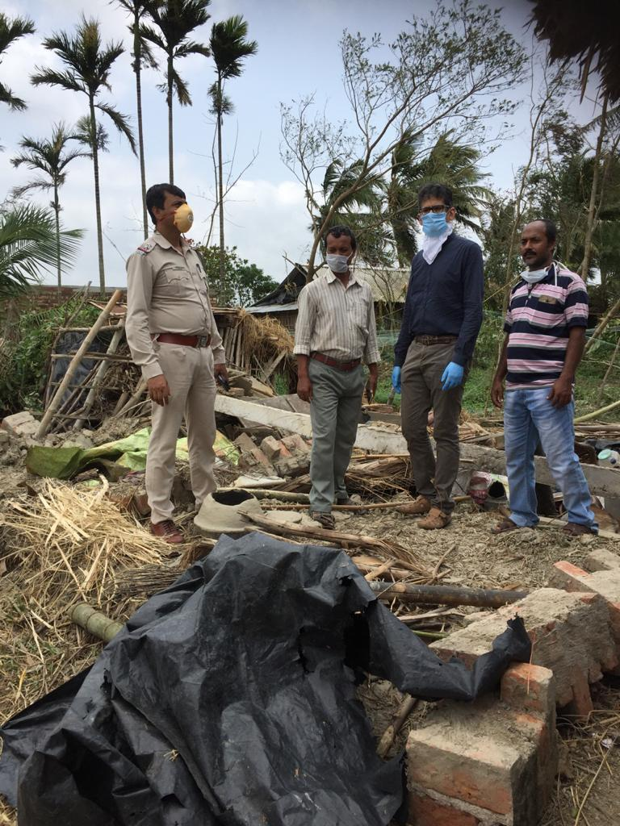
Traveling to Sundarbans is strictly restricted and nobody can go there without permission. Jaydeep and his team of 15 people from Meghdutam Foundation under police escort and with the help of local government administration in Sundarbans took a three-hour journey to carry the relief packages to the villages in hardship. They also had to take a boat to reach the delta. According to Jaydeep, they visited Sundarbans 8 times in 45 days. Apart from the packages of food, the team carried with them clothing for the villagers, mosquito nets and tarpaulins to cover the roofs of damaged houses.
Jaydeep praised the help and support of all those people who sacrificed their time and energy to take the hands of other people in need on the frontline and backstage. Jaydeep particularly mentions the heroic story of an 87-year-old woman who has relentlessly stood by the aid workers since the start of the pandemic. Ms Kanta Devi Karnani who is originally from Kolkata has lived her life with her family in London. She regularly made short visits to Kolkata and returned to London, but since her last visit she has been stuck in Kolkata due to the flight bans. Jaydeep told me, “Kanta had to stay in her house in Kolkata while all her family are in London.” Jaydeep continues, “Instead of slipping into a much expected physical and mental low, she kept her will high by helping the relief workers of the non-governmental and non-commercial charitable organisation of Meghdutam Foundation.” Kanta, with the help of her servant cooked food for 15 members of Meghdutam every day for the past 4 months. Her sons, who have a factory in the UK, have also donated funds for the cause of the Meghdutam Foundation.
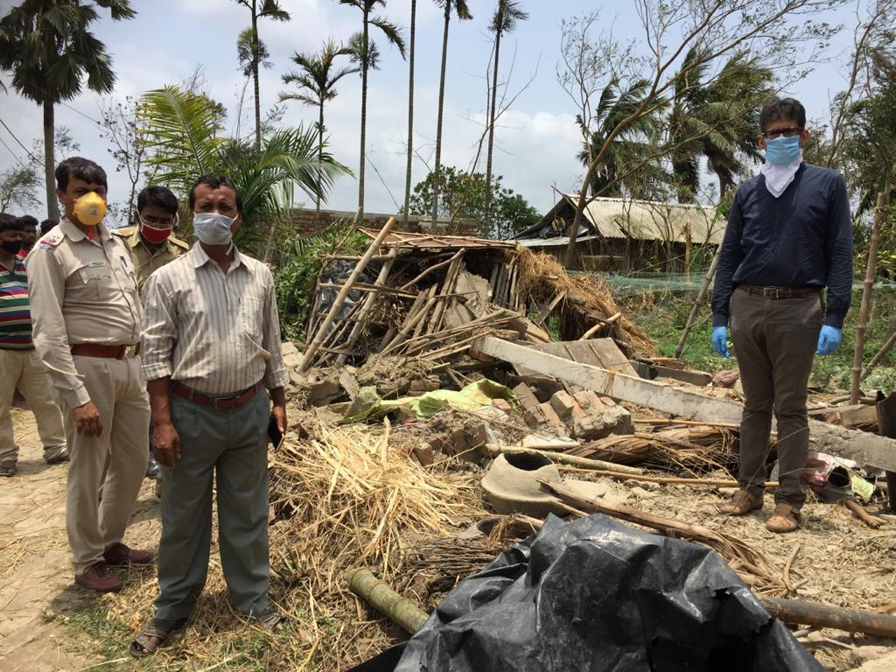
The world is witnessing a new era on the face of the pandemic. The state of Bengal and the city of Kolkata are arguably suffering more than any other places in the world. The people in Kolkata and Sundarbans live amidst fragile infrastructure, poorer and in more vulnerable situations than any other parts of India. However, Jaydeep and other aid workers with the care of government organisations and other NGOs bring hope and faith to vulnerable and helpless people.
It is unlikely that the Durga Puja Festival would be celebrated on the streets again in October 2020, but surely all people of Kolkata stand together in prayers whether Hindu, Muslim or Christian, to the ultimate being, Brahma, Allah or God, praying for the end of the coronavirus.
To support Meghdutam Foundation contact:
www.meghdutamfoundation.org
